Findings about Falun Gong’s Health Effects:
- Falun Gong’s disease healing rate is 99.1%;
- Cure rate is 58.5%;
- Improvement rate is 80.3% in physical health;
- Improvement rate is 96.5% in mental health.

Summary:
To determine the health effect of Falun Gong, we conducted a survey among some Falun Gong practitioners in five districts in Beijing, with 12,731 valid questionnaires. Our results show that Falun Gong’s disease healing rate is 99.1% with a cure rate of 58.5%; Improvement rate is 80.3% in physical health and 96.5% in mental health. The survey indicates that Falun Gong has significant effects in disease healing and health promotion. Falun Gong is an excellent Qigong that benefits people both physically and mentally.

Study Population:
In 1998, we conducted the survey on over 200 practice sites in five districts (West, Chongwen, East, Xunwu, and Chaoyang) in Beijing. We collected 14,199 questionnaires with data comparing the health status of practitioners before and after Falun Gong practice.

Study Design and Method
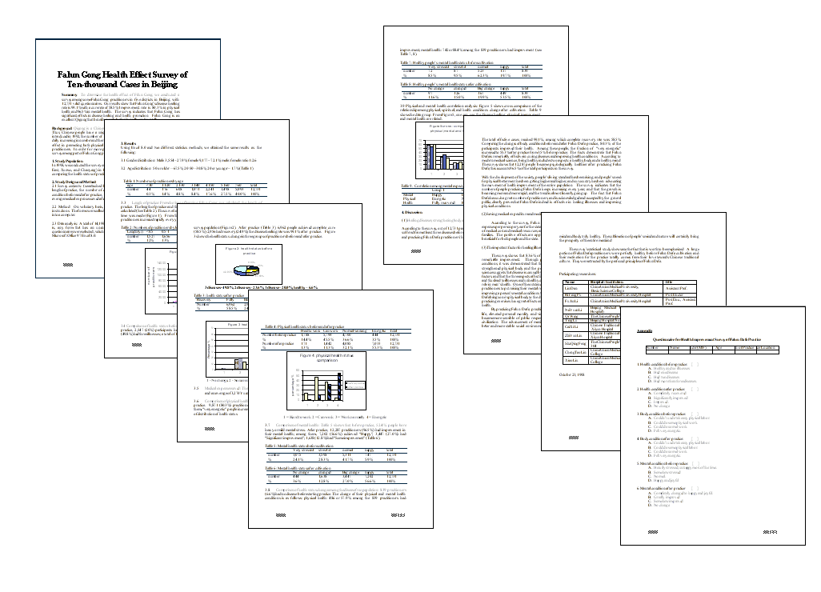
Survey contents: (see attached Falun Gong Health Effect Questionnaire) Name, sex, age, length of practice, the number of different diseases before and after practice, physical heath condition before and after practice, mental health condition before and after practice, and the average medical expenses saved after practice.

Method: On voluntary basis, the participants filled out the questionnaires according to instructions. The forms were collected and organized by designated people. The data was input into a computer.

Data analysis: A total of 14,199 forms were collected. A uniformed criterion was made, that is, any form that has an unanswered item will be excluded. 12,731 valid completed questionnaires were selected, which were used for final valid data. The data was analyzed with Microsoft Office 97 Excel 8.0.

Participating institutions:
China Union Medical University, China Union Medical University Hospital, Beijing Medical University, The Chinese People's Police General Hospital, Beijing Hospital No.2, Chinese Traditional Medicine Research Institute, The Chinese People's Military General Hospital 304, China Union Medical University

1 - No change, 2 - Some recovery, 3 – Almost recovered, 4 - Completely recovered.
To see the full report, or to get a list of participating researchers, please visit: http://minghui.ca/eng/science_eng/survey98_1eng.htm

For the full survey “Falun Gong Health Effect Survey of Ten-thousand Cases in Beijing“or a complete list of participating organizations, please visit: http://minghui.ca/eng/science_eng/survey98_1eng.htm

