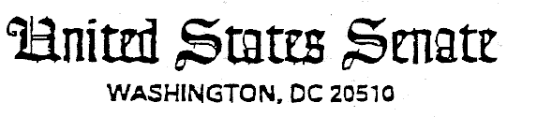
August 6, 1999

His Excellency
Jiang Zemin
President of the People's Republic of China
Beijing, China

Dear Mr. President:

As members of the United States Senate, we are deeply concerned about the official banning of Falun Gong and the arbitrary detention of some of its organizers and followers. While we do not necessarily endorse this group or its beliefs, we firmly support the fundamental human rights enumerated by the Chinese constitution and the international norms of freedom of belief, expression, and assembly. We therefore urge the immediate release of those detained and trust that none of them will be charged and tried for the peaceful expression of their beliefs.

There have also been disturbing reports of beatings and other mistreatment of Falun Gong practitioners who were recently detained in cities across China, many of whom have since been released. We urge the Chinese government to thoroughly investigate these reports.

We are also concerned about the decree that the Ministry of Public Security issued on July 22, declaring a wide range of activities illegal and subject to prosecution, includng distribution of Falun Gong materials, gatherings or silent sit-ins, marches or demonstrations, or other activities to promote Falun Gong. This decree seems to contradict the promises China made to protect basic human rights when it signed the International Covenant on Civil and Political Rights in October 1998.

China took positive steps by inviting the U.N. Special Rapporteur on Riligious Intolerance to visit China in 1994, and a high-level U.S. religious delegation to visit China and Tibet last March. However, these recent actions call into question China's willingness to accede to international norms by protecting rights of religious belief, freely and peacefully expressed.

A reversal of this ban and the release of those detained will help to improve the American public's view of China, as well as U.S.-China relations, and it will certainly help to enhance China's image in the international community. We hope that the Chinese government can take these affirmative steps.

We appreciate your attention to this matter.

Sincerely,

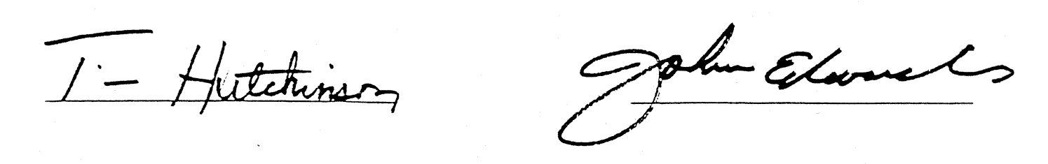
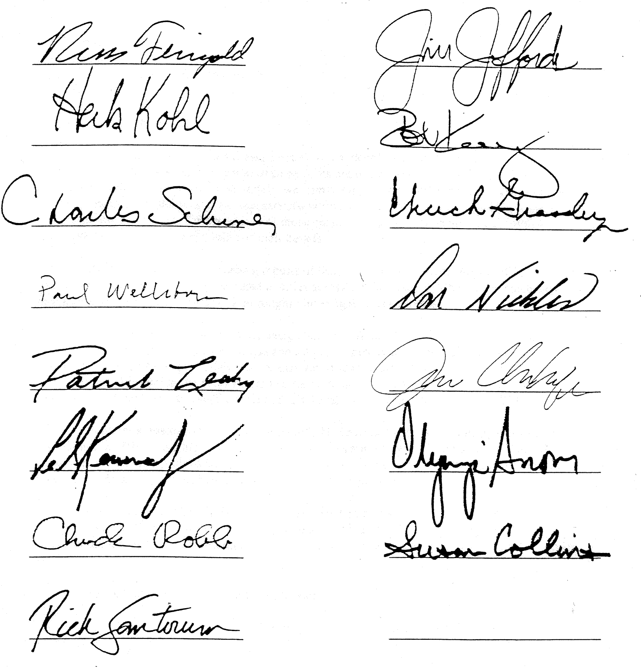

August 6, 1999

His Excellency Jiang Zemin
President
The People's Republic of China
Beijing, China

Dear President Jiang:

We are writing to express our concern and dismay over the repression of practitioners of Falun Gong.

This policy of repression does not befit a confident great power. As a signatory of the United Nations Covenant on Civil and Political Rights, China should uphold the rights of practitioners to freedom of expression and assembly, whether or not your government agrees with the group's philosophy. As China continues to become integrated into the global economy, it must uphold the international norms to which it has agreed.

We sincerely hope that this policy is not a sign of a rejection of the global integration and economic reforms that your government has pursued. We ask you to stop the crackdown against Falun Gong practitioners, release those already arrested, and allow your citizens freedom of expression and assembly.

Yours truly,

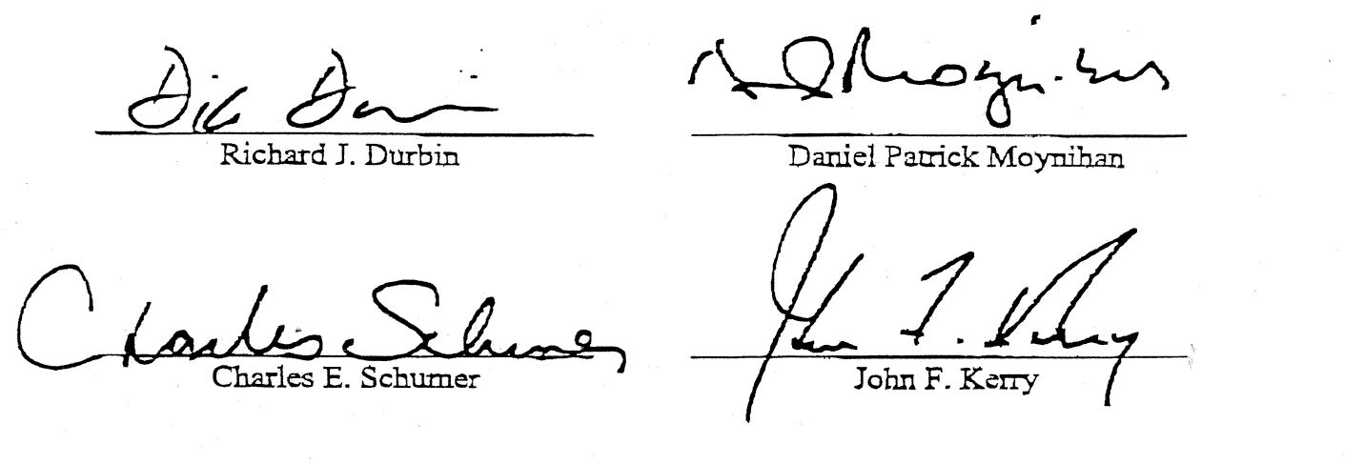

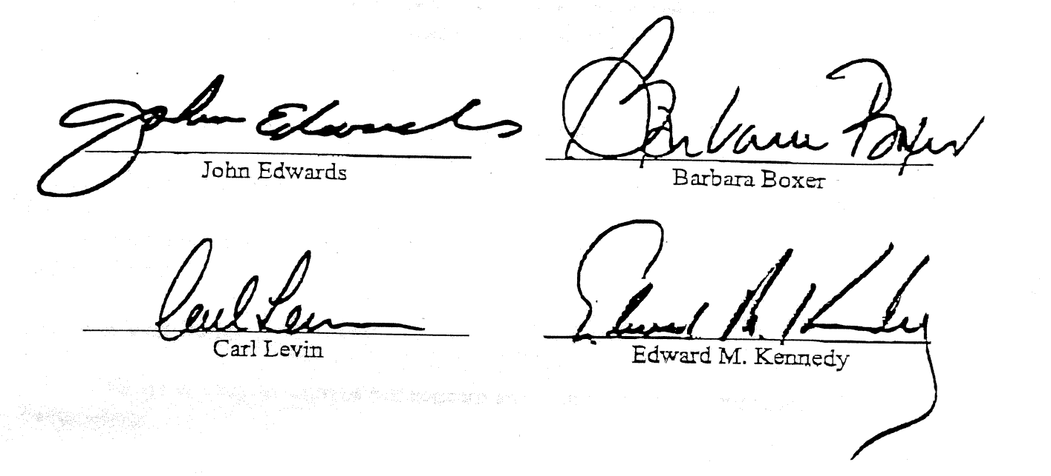


September 10, 1999

The Honorable Madeline K. Albright
Secretary of State
Department of State
2201 C Street, N.W.
Washington, D.C. 20520

Dear Madam Secretary:

We write out of concern over the current crackdown against Falun Gong practitioners in China. As you know, the recent arrest of hundreds of Falun Gong practitioners provides fresh and disturbing evidence of the lack freedom of expression and assembly in China and of the Chinese government's blatant disregard for human rights.

When over 10,000 Falun Gong practitioners assembled peacefully in April to ask for official recognition, the Chinese government reacted by viewing the request as a threat to its power. As a result, on July 22nd, the Chinese Ministry of Civil Affairs denounced Falun Gong as an illegal organization banned its practice in public or private throughout China. On the same day the Ministry of Public Security issued a decree declaring a wide range of activities illegal and subject to prosecution, including distribution of Falun Gong materials, gatherings, silent sit-ins, marches, demonstrations, and other activities which promote Falun Gong.

We are extremely concerned about these actions by the Ministry of Civil Affairs and the Ministry of Public Security. The scope of the arbitrary detentions of the members of the members of this non-political organization is astounding, and the decree issued by the Public Security Bureau violates the rights to freedom of belief, association and assembly which are guaranteed by the Chinese constitution and international law.

We ask you to speak out against this recent crackdown and to work with the international community to secure the release of the hundreds of the organization's members arbitrarily detained during recent weeks.

Than you for your attention to this matter. We look forward to your reply.

Sincerely,

Signed by John Edward Porter, Tom Lantos, James A. Traficant, Eleanor Holmes Norton, John W. Olver, Joseph R. Pitts, Stephen Horn, Edolphus Towns, John Joseph Moakley, David Dreier, Barney Frank, Edward J. Marker, James P. McGovern, Robert Wexler, Christerpher Shays, Eliot L. Engel, Spencer Bachus, Frank Wolf, Nita M. Lowey, Howard L. Berman, James M. Talent, Kenny C. Hulshof, Ron Lewis, David Price, Neil Abercromble, Janice Schakowsky, Henry Waxman, Barbara Lee, John F. Tierney, Dennis J. Kucinich, Rod R. Blagojevich, James H. Maloney, Louise McIntosh Slaughter, Robert L. Ehrlich, Centance A. Morelh, Christopher H Smith, Julian C. Dixon, Bruce F. Vento, Bob. Clement, James Morgan.

