René V. L. Wadlow
Permanent Representative
United Nations, Geneva

Dear Friend,

I write to you to ask for your help to urge the Government of the People's Republic of China to lift its ban on the spiritual movement Falun Gong. This ban of 22 July 1999 has been followed by constant attacks in the Chinese press and television. There has been widespread and public destruction of books and video material. The police have broken up Falun Gong practice in public parks and other public meeting places. At least 100 Falun Gong leaders are being held for trials which may start soon.

I enclose a brief article The Ban on Falun Gong and the After-Shocks which includes part of my 4 August 1999 presentation to the UN Sub-Commission on Human Rights and the reply of the Chinese Ambassador Qiao Zonghuai.

The ban on the Falun Gong is a direct violation of the Declaration on the Elimination of All Forms of Intolerance and of Discrimination Based on Religion or Belief which has been accepted by the Chinese government.

I am sure that you share my conviction that the right to follow a spiritual path is of particular importance in this period of transition. Therefore, I welcome your help. I believe that a letter to the Premier of China at this time would be a sign of your interest:

Premier Zhu Rongji
State Council
Guowuyuan, 9 Xihuangchenggenbeijie
Beijing 1000032, People's Republic of China

In your letter to the Chinese Premier you could stress three points:

- The importance of the spiritual path both for the development of the individual and for the welfare of the society.

- Freedom of belief and exchange of ideas are essential to human progress.

- The ban on the Falun Gong should be lifted so that China will be in accord with universal standards concerning freedom of thought.

I would be pleased if you would share my letter and article with your friends. I would be pleased to stay in touch and give you news as the situation develops.

With best wishes,
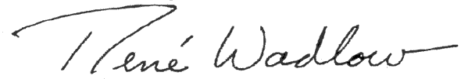
René V. L. Wadlow
Permanent representative of United Nations, editor of Transnational Perspectives (a journal of world politics and social issues), and formerly Professor and Director of Research of the Graduate Institute of Development Studies of the University of Geneva.

